**Assignment**

**HTML Form Styling and Website Layout Practice**

In this assignment, you will practice creating an HTML form with various input types and styling it using CSS. Additionally, you will create a website layout using CSS float property to wrap text around image content effectively.

**Instructions:**

1. **Setup Environment:**
   * Create a new directory for your project.
   * Inside the project directory, create an HTML file (e.g., **index.html**) and a CSS file (e.g., **styles.css**).
2. **Create HTML Form:**
   * In the HTML file, create a form element (**<form>**) to contain all the input fields to acquire different inputs from the use.
   * Inside the form, add various input types including text box, text area, dropdown menu with different options to select from, button, checkbox, label, radio button, date picker, and password field.
   * Use appropriate HTML tags also for data picker, uploading files from system such as **<input>**, **<textarea>**, **<select>**, **<button>**, **<label>**, **<radio>**, and **<checkbox>**.
   * Examples <input type=”text”/>, <input type=”email” />,

<input type=”date”>

1. **Add CSS Styling:**
   * Link the CSS file to your HTML file using the **<link>** tag.
   * In the CSS file, style the form elements to improve their appearance.
   * Apply styles for input types, labels, buttons, and any other elements you've used in the form.
   * Use CSS properties such as **color**, **background-color**, **font-size**, **padding**, **margin**, **border**, etc., to style the form elements.
   * To make form see through you can use CSS property **background: transparent.**
   * Ensure that form is visually appealing and user-friendly.
   * Use **required** attribute for fields which are mandatory.
   * Use **minlength** attribute to make sure user enters at least **6** characters inside password field.
   * Optional (you can use attribute **multiple** to upload multiple files)
2. **Create Section using CSS float Property:**
   * Define a layout for your website using **HTML** and **CSS**.
   * Utilize the float property to position images wrapped inside text within your layout.
   * Use appropriate HTML tags. Horizontally divide your page into three sections each section will contain image adjust the images position with float property.
   * Apply float property to position elements horizontally within the layout.
3. **Testing and Refinement:**
   * Test your HTML form and website layout in different web browsers to ensure cross-browser compatibility.
   * Ensure that the form functions correctly and the layout appears as intended.
   * Make adjustments to the HTML and CSS as needed to improve the design and functionality.
4. **Submission:**
   * Submit your HTML and CSS files along with any other necessary assets (e.g., images) in a zip file.
   * Include a brief description of the form elements used and the layout of your website.
   * Optionally, provide screenshots or a live demo link for visualization.

**Demo Form Layout:**

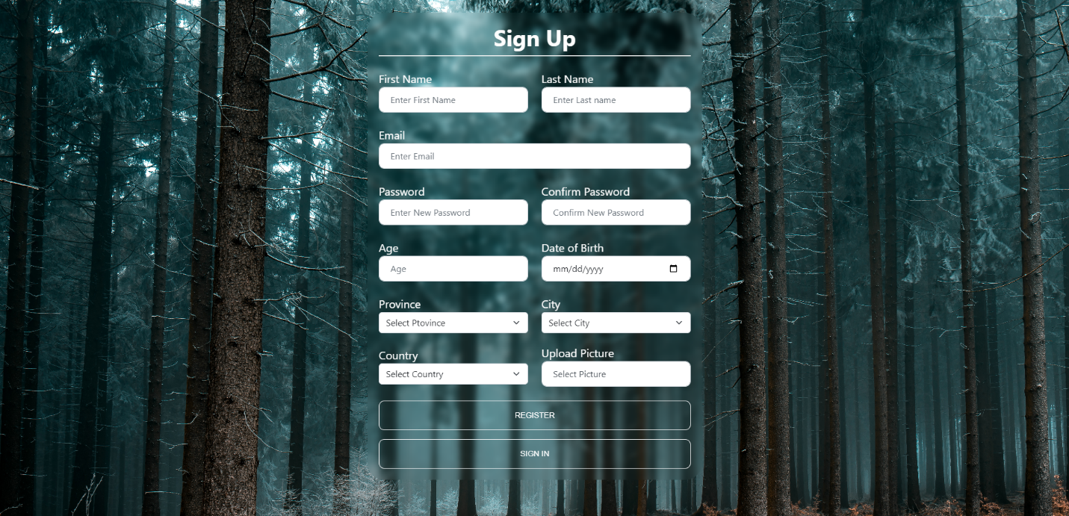

**Demo Example For Float Layout:**

